
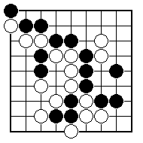
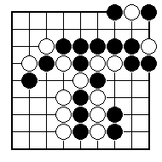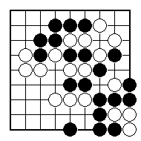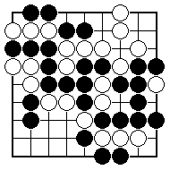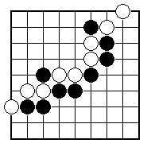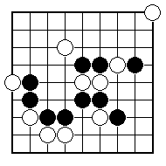
How many stones are in atari? Mark them all.

How many stones are in atari? Mark them all.

Mark the stones that should have been taken off.

Which stones are captured and should be taken off?
Show all Black plays which would put White in atari.

Show all Black plays which would put White in atari.

NAME:
BRITISH GO ASSOCIATION CERTIFICATE LEVEL 1 - SHEET 5

MORE ABOUT ATARI AND CAPTURING

